Chesil Sailability
Use of Life Jackets and Buoyancy Aids.

Present Position.
Sailors and Volunteers attending Chesil Sailability sailing sessions are required to wear a standard 50 Newton Buoyancy Aid. If they do not own one personally they are issued one at the start of each session from Chesil Sailability loan stock. This loan equipment is checked for suitability and fit by the Pontoon Link volunteers at the time of issue. Any defective equipment is withdrawn from use until repaired or replaced.

Some volunteer members have their own life jackets and choose to wear these for sessions. These jackets are not inspected by other CS volunteers for suitability or fit as it left to the personal responsibility of each volunteer to maintain their own property.

Instances of sailors, carers or volunteers falling into the water are very rare, and the likelihood of a capsize in our keel boats and Hansa Class dinghies is slight. in the event of a sailor entering the water the skippers primary concern is to ensure where possible that they are footing the right way up. Safety Boats are always present during Chesil Sailability sailing sessions.

Purpose of this policy.

Chesil Sailability Sailors, Carers and Volunteers are drawn from a wide range of body types and swimming abilities, ranging from fully fit strong swimmers with a good sailing back ground to people without the full use of their arms and legs or without the capacity to act to protect themselves in the event of entering the water. The charity needs to develop a policy that recognises that whilst the risk to members entering the water cannot be completely eliminated, the provision of the most suitable protective equipment for each person can reduce this risk to an acceptable level.

Type of protective equipment available in the recreational sailing market.

Buoyancy aids are simply that - an aid to buoyancy that generally relies on help being close at hand. It assumes that the wearer is able to help themselves to some degree by swimming to safety or by keeping themselves afloat while assistance arrives if required.

A lifejacket is intended for use where a high standard of performance is required. It will turn an unconscious person into a safe position and requires no subsequent action by the user to maintain this position.

(http://www.rya.org.uk/knowledge-advice/safe-boating/look-after-yourself/Pages/buoyancy-aids-lifejackets.aspx)

Buoyancy Aids and Lifejackets must conform to BS EN 393 to BS EN 399. Buoyancy can be provided in a variety of ways, ranging from permanently buoyant material to inflatable chambers or combinations of both.

Buoyancy is measured in Newtons (N). Ten Newtons equals 1kg of flotation.

Buoyancy Aids.
These are available in two standard sizes 50N and 100N.

50 N. BS EN 393 have a buoyancy of no less than 50 Newtons for the average adult and are intended for use in sheltered waters when help is close at hand and the user is a swimmer. They are worn where more bulky or buoyant devices would impair the user’s activity or actually endanger them.

100 N. BS EN 395 have a buoyancy of no less than 100 Newtons for the average adult and are intended for use in relatively sheltered waters when normal clothing is being worn and the wearers remain capable of helping themselves.

These products are NOT guaranteed to self-right an unconscious person wearing waterproof clothing and should not be expected to protect the airway of an unconscious person in the water.

Life Jackets.

150 N. BS EN 396 have a buoyancy of no less than 150 Newtons for the average adult and are intended for use in tidal waters or when foul weather clothing is being used. They are worn where the wearer may not be capable of self help due to injury or exhaustion (or where there may be a delay in rescue). They give reasonable assurance of safety from drowning, to a person not fully capable of self help (ie someone unconscious).
However, they may not immediately self-right an unconscious person wearing heavy waterproof clothing that might trap air which may counter-act the normal righting moment of the lifejacket’s buoyancy.

275 N. BS EN 399 have a buoyancy of no less than 275 Newtons for the average adult and are intended for use in tidal waters in extreme conditions, when heavy protective clothing is being worn or loads such as tool belts are being carried.They are worn where the wearer may not be capable of self help due to injury or exhaustion (or where there may be a delay in rescue).
These products give improved assurance of safety from drowning, to people who are not able to help themselves (ie unconscious).
While they cannot be guaranteed to immediately self-right an unconscious person wearing heavy waterproofs that might trap air, the buoyancy they provide should ensure they will do so in the majority of cases.

Risks.
There is a risk of any design of personal buoyancy equipment failing to operate correctly, or at all, if it is not properly used and maintained. It should be recognised that manufacturers design and develop protective equipment with a standard human body as part of the requirement.

Many of our sailor’s bodies do not conform to the standards used by the developers and therefore all equipment may function differently or not at all. Testing by the Royal Yachting Association with the co-operation of life jacket manufacturers and Sailability Sailors has shown that this failure rate can be as high as 20%.

Chesil Sailability safety standards.

- Chesil Sailability provides a high level of safety with the utilisation of vessels with a reduced likelihood of capsize and with positive buoyancy to reduce the likelihood of sinking.
- Sailing sessions take place in the sheltered waters of Portland Harbour.
- At each sailing session, dedicated safety boat cover is provided to enable a response to any incident in under 10 minutes.
- Sailing sessions are limited in terms of both wind and sea conditions as these are monitored at all times by the Chesil Sailability Duty Officer.
- Each vessel is commanded by a volunteer or sailor assessed by the trustees as competent in the handling of that vessel type.
- Wheelchair Users entering the Pontoon Area are unclipped from their wheelchairs before leaving the top of the ramp and only clipped back in when away from the pontoon.

Limitations.
Chesil Sailability provide a range of buoyancy aids and life jackets to offer a high degree of assurance in the event a sailor, carer or volunteer enters the water, they will be protected from drowning.
This policy recognises that Chesil Sailability Sailors have a wide range of both learning and/or physical disabilities. As such, an individual sailor‘s ability to protect themselves from drowning may be severely compromised.

Decision making.
The decision making process as to which flotation aid is to be worn will involve the sailor and where appropriate their carer, parent or guardian. The decision will normally be a one off discussion which will apply to subsequent sessions. This will be reviewed if circumstances change and at the start of each season.

Swimmers Physically Fit and Disabled
Should be asked if they are able to tread water for at least 3 minutes. They should be issued with a properly fitted 50N Buoyancy Aid.

Non Swimmers. Physically Fit and Disabled
If unable to support themselves in the water. Should be issued with either a 100N buoyancy aid or 150N auto inflating Life jacket. The 100 N Buoyancy aid may be suitable for issue to members who could misuse an auto inflating life jacket by accidental or deliberate activation.

Members Personal Equipment
If a member wishes to use their own personal protective equipment they should be asked to positively indicate that they have considered the protection that it offers and that it is fit for purpose. This should be recorded on the tally sheet.
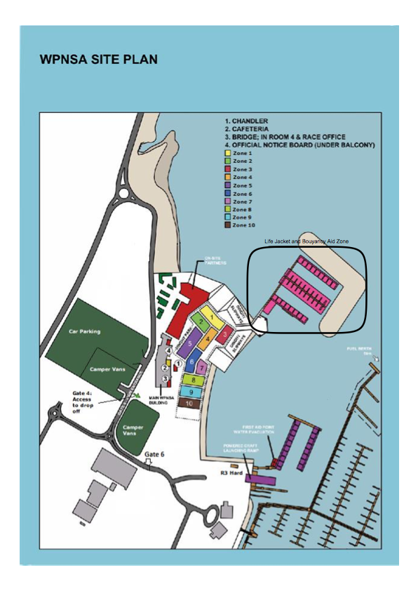

Life Jacket and Buoyancy Aid Zone.
Life Jackets and Buoyancy Aids will be worn by all sailors, carers, volunteers and visitors, from the top of the pontoon access ramp for the whole period on the pontoon or onboard a vessel until they return to the top of the pontoon access ramp.
Outside this zone protective equipment will be worn at all times when within 2 meters of the water for any purpose. ie slipways, other vessels, pontoons and cranes.

Storage and Maintenance.
Lifejackets and Buoyancy Aids need to be stored in suitable dry conditions.
When storing lifejackets and buoyancy aids:
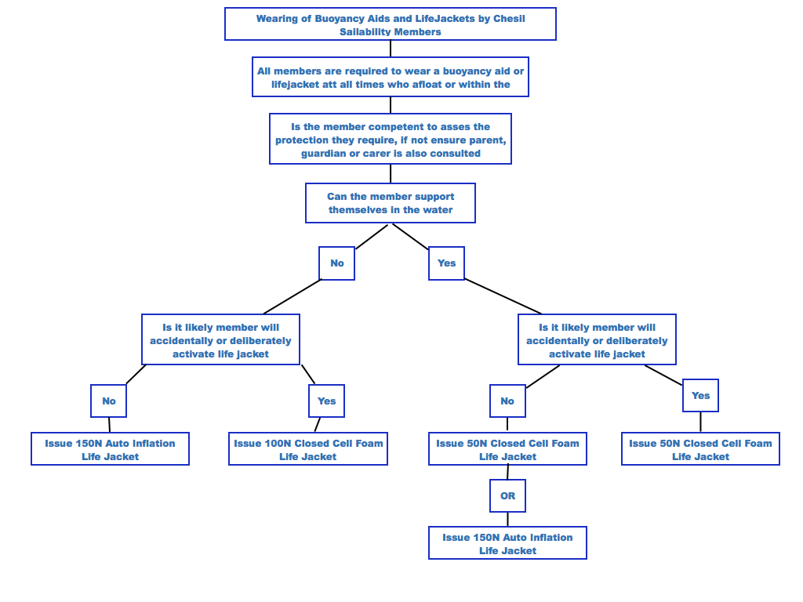
■ Do not hang lifejackets and buoyancy aids with wet oil skins or other damp clothing.
■ If the lifejacket is wet, unpack it and leave it to dry out on a hanger.
■ Do not store lifejackets and buoyancy aids close to or directly above heat sources, eg convection heaters.
■ Do not store lifejackets upside down. This is to prevent water getting in to the automatic initiation mechanism.
- Make sure there is enough space around the lifejacket or buoyancy aid, when it is stored, to allow the air to circulate.
Chesil Sailability equipment will be stored on a hanging rail inside Reception Cabin.

All equipment will be subject to an inspection before issue and maintained in accordance with the manufacturers care instructions.

Protective Equipment Issue Flow Chart.

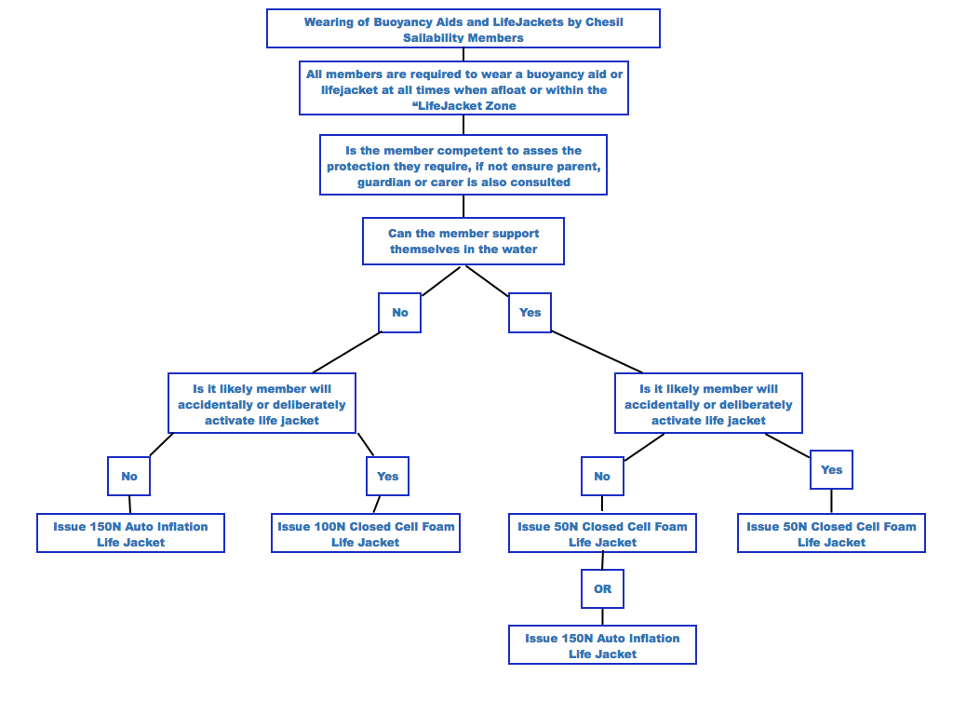

Bibliography.

http://www.hse.gov.uk/pubns/ais1.pdf

http://www.safety-marine.co.uk/spages/how-to-choose-a-lifejacket.htm

http://completeguide.rnli.org/lifejackets.html

